
Gardewine POC
April 2nd 2026
Proof of Concept for Gardewine

Introduction
This Proof of Concept (POC) is designed to evaluate i3 International’s ability to support Gardewine in improving workplace safety, operational visibility, and risk mitigation across its facilities.
Following internal exposure to Protex AI, Gardewine is seeking a solution that can identify, track, and report unsafe or risky behaviors while integrating seamlessly with existing infrastructure.
The POC will be conducted at the Toronto terminal to validate real-world performance and determine scalability across the organization.

POC – What we are trying to accomplish
1. Replace or enhance current VMS limitations (Immediate focus)
- Current system is basic and not delivering meaningful value
- i3 must demonstrate it can act as:
  - A modern VMS
  - A data-driven platform that improves visibility and operations
2. Deliver value at a practical price point
- Competing solution is high cost and difficult to scale
- i3 must prove:
  - Strong operational insights
  - At a price point that enables company-wide adoption
3. Validate real, usable health & safety data (Phase 2)
- Once the platform is in place, prove we can:
  - Capture quantifiable safety incidents
  - Deliver clear, actionable reporting for leadership
4. Help reduce incident rates
- Use the data to identify patterns and drive behavior change
- Objective is to lower incident frequency and improve safety performance
5. Prove scalability across the business
- Start with single site (Mississauga/Toronto)
- Demonstrate ability to roll out across all locations efficiently

Gradenvine Commitment (if the technology works)
1. Broader deployment across locations
- Expand from pilot to company-wide rollout
2. Position i3 as core platform
- i3 becomes:
  - Primary VMS
  - Foundation for operational and safety data
3. Phase 2 expansion of advanced capabilities
- Add deeper AI use cases over time:
  - Forklift behavior
  - Speeding
  - Advanced safety analytics
- Build on the base platform once value is proven
4. Long-term partnership
- Transition from pilot to embedded operational solution tied to safety, compliance, and brand protection

Network Layout:
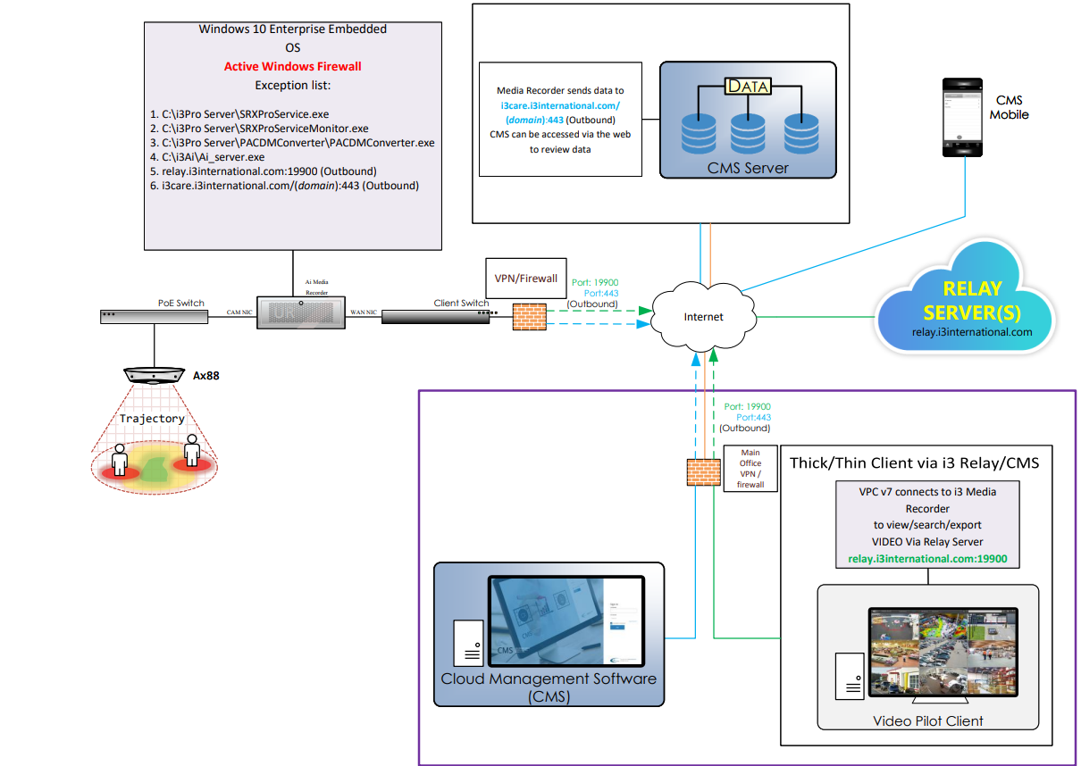

Price Breakdown
Pricing to be determined following the site walkthrough and confirmation of required equipment, software, and deployment scope.

*Does not include installation. Installation cost to be provided by SI ALARMS

Timeline
POC Kickoff / Walkthrough: To be scheduled – April
Installation & Configuration: Following walkthrough
Analysis Phase: 45-day data collection and validation
Review & Decision: Executive review and next steps

Commitments
From i3 International:
- Provide AI-driven video analytics platform and required hardware/software (as scoped).
- Support deployment, configuration, and validation of the POC.
- Provide ongoing support and alignment throughout the evaluation period.
- Deliver reporting and insights aligned to POC objectives.

From Gardewine:
- Provide access to existing infrastructure and network configuration.
- Participate in walkthrough, validation, and review sessions.
- Provide feedback and operational input during the POC.
- Collaborate with i3 and SI Alarms for deployment and testing.

Approval: By signing below, you agree to the terms outlined in this proposal.
Gardewine i3 International
Client Signature: _____________________ i3 Signature: ________________________
Name & Title: _Chris Lytwtn_IT Director_ Name & Title: __Vy Hoang, CCO_______
Date: ____Apr.2nd , 2026____ Date: ____Apr.2nd, 2026____

For any questions or modifications to this agreement, please contact the sales rep designated for your account. Thank you for choosing i3 International!

i3 Contact Information
- CCO : Vy Hoang
Email: vhoang@i3international.com
Tel: 716-783-0986
- Channel Manager Contact: Andrew Ezechiels
Email: aezechiels@i3international.com
Tel: 716-998-2357
- PM/Technical Support: Nissan Brito
Email: nibrito@i3international.com
Tel: 716-336-6307
SI ALARMS - Contact Information
- CEO: Joe Putaro
Email: joe@sialarms.com
Tel: 204-231-1606 ext 502
Gardewine Contact Information
- IT Manager: Chris Lytwtn
Email: chrislytwyn@gardewine.com
Tel: 204-633-5795

Closing Notes
The successful completion of this POC will establish a foundation for improved safety, reduced operational risk, and enhanced visibility across Gardewine’s facilities.
All activities will be tracked and aligned to ensure measurable outcomes and a clear path to broader deployment.

